BYZANTINE ICON PAINTING WORKSHOP
Taught by Susan Kelly vonMedicus, Prosopon School of Iconology
affiliate instructor
Monday May 20 through May 24, 2024 9 am-4pm
Church of the Holy Faith Church 311 E Palace Ave, Santa Fe, NM
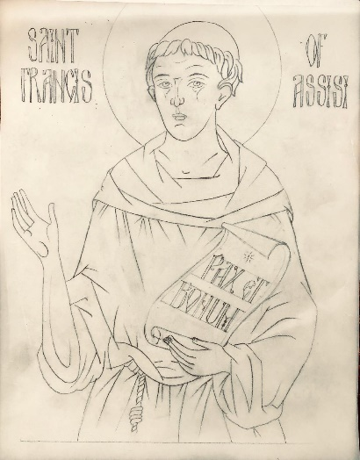

Emphasis is placed on personal spiritual discipline and growth through a study of Christian Church teachings and principles as practiced in the making of icons. The Prosopon School is founded by and the theory and methods are under the direction of master iconographer Vladislav Andrejev. Classes are taught in the traditional Russian style Byzantine Icon painting using egg tempera based natural pigments and 23K gold leaf on gessoed wood panel
SUBJECT: St. Francis of Assisi with scroll for experienced students, head and shoulders for beginners
No previous artistic experience is necessary for the icon workshop, all are welcome.
Tuition $500.00 (5 days), includes teacher transportation and tithe to church and larger school
Materials fee $170.00, includes all needed- gessoed wood panel, 23K gold leaf, natural hair brushes, mineral pigments, egg tempera, study guides. If advanced students have their own materials such as board and brushes there will be a credit given.
There is a minimum of 8 students needed to hold the workshop, maximum 15. Please register promptly to hold your place.

REGISTRATION

Name:

Email:

Phone number:

_____ I am a first time student
_____ I am a continuing student
For continuing students, _____I will supply my own board, gold and brushes. Please indicate any of these you will provide. Pigments, basic tools will be supplied by teacher so you do not need to pack up and move your whole studio.

To register please send deposit* of $300.00 to
Susan Kelly vonMedicus
661 Church Road
Flourtown, PA 19031
Or paypal : eikon68@aol.com
*(non-refundable in event of student cancellation, fully refundable if for any reason the teacher needs to cancel the workshop)

Questions please email Susan vonMedicus at eikon68@aol.com

To see artwork by the teacher please visit www.susanvonmedicus.com

