LATE GOTHIC FILIGREE ILLUMINATION CERTIFICATE
Taught by Susan Kelly vonMedicus
2024
Friday May 17, 6-8 pm Saturday & Sunday May 18, 19 1-4 pm
Church of the Holy Faith Church 311 E Palace Ave, Santa Fe, NM

Design and make a Birth, Baptism or Mariage certificate in the style of the Spanish Hymnals of the 14th C

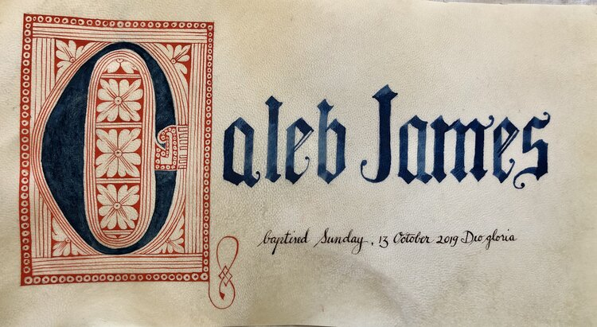

3 sessions - $ 120.00 materials $ 40.00
Minimum 6 students maximum 18
Please send registration with 50% deposit* ($80) – please include name and email and phone number.
Susan Kelly vonMedicus 661 Church Road Flourtown, PA 19031 or paypal at eikon68@aol.com
Questions? Eikon68@aol.com
see artwork at www.susanvonmedicus.com
*deposits non-refundable for student cancellation, if teacher cancels the workshop deposits will be refunded

